

Release Notes

Table of Contents
Introduction........................................................................................................................................2
Prerequisite.........................................................................................................................................2
Install....................................................................................................................................................2
Start Redis............................................................................................................................................2
Run Hubot............................................................................................................................................2
Functions Supported..........................................................................................................................2
Known Issues.......................................................................................................................................3
Configure bot in slack........................................................................................................................3

Introduction:

Hubot task bot provides task managemnt facilities like addition, deletion, updation and listing of tasks.
This document communicates the prerequisite and installation steps for task bot. It also document the know issues.

Prerequisite:

1. Node.js - Version >= 0.10.32
2. npm - Version >= 2.13.2

Install:

1. Copy scripts(install.sh and config.sh) to folder where you want to install Hubot and Redis.
2. Execute install.sh
3. After successfully installing Hubot and Redis, execute config.sh
4. Remove all files from taskbot/scripts and add file todo.coffee
* todo.coffee – Download latest file from
https://github.com/vishals79/hubot-todo/tree/master/src/scripts

Start Redis:

1. Navigate to folder installed redis folder.
2. src/redis-server

Run Hubot:

1. Navigate to folder taskbot
2. HUBOT_SLACK_TOKEN=API_Token ./bin/hubot -a slack

* API_Token = Token of your bot configred in slack. To know how to configure bot, go to Configure bot in slack section.

Functions Supported:

* help = To display the list of available commands.

* add|create <task-description>

task_number = last added task, if <task_number> is not provided

* update <task_number> <task-description>

* delete <task_number|all>

* show <task_number>

* note <task_number> <note-description>

* complete <task_number>

* time <task_number> <time in the format hh:mm>

* date <task_number> <date in the format DD-MM-YYYY>

* date <task_number> today+n

* list

* subtask <description> for <parent-task-number>

* default time HH:MM

* default date today+n

* default date <DD-MM-YYYY>

* assign <task_number> @User_Id : Assign task to User_Id

* notifications : Display Notifications

* accept <task_number> : Add task to your list and delete the notification.

* reject <task_number> : Assign task back to the assignor and delete the notification.

* clear: Clear all notifications

Known Issues:

1. Date Format: User has to enter date in the format DD-MM-YYYY. This is a constarint and system should provide better and easy way to enter date.

Configure bot in slack:

1. Go to “Configure Integration”

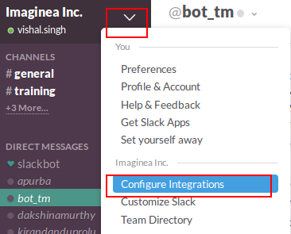

2. Search for “hubot” under “All Services”. Click on view and add “Hubot Integration”.

